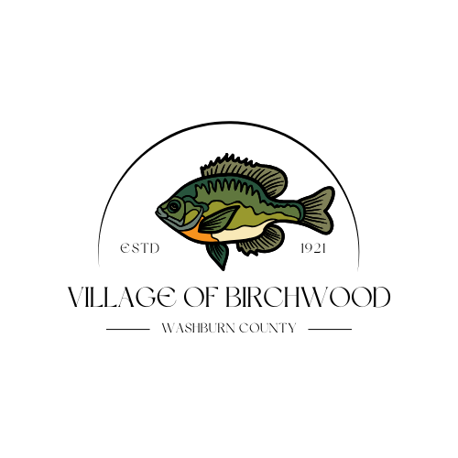

Building Inspector Fee Schedule
Village of Birchwood

Single-Family New Home
$700 base rate + $0.40 per sq ft

Two-Family Twin Home and Duplex New Home
$800 base rate + $0.40 per sq ft

One- & Two-Family Alteration/Remodel
$100 base rate
Additional $35 for each (electrical, plumbing, HVAC)

One- & Two-Family Additions
$350 base rate +$0.40 cents per sq ft

Manufactured Homes
$700 base rate
Additional $75 additional fee for decks and stairs more than 3 risers.

Mobile Homes (new/used)
$350 base
Additional $75 additional fee for decks and stairs more than 3 risers.

Raze
$75 base rate

Detached Garages and Sheds (permanent) $150 base rate
Additional $35 for each (electrical, plumbing, and HVAC)

Portable Structures (car ports, yard barns, and garden sheds)
$35 base rate
Additional $35 for each (electrical, plumbing, and HVAC)

Roofing, siding, doors and Windows (replacement)
$35 base rate for each

Decks (exceeding 24” in height, 6x6 or larger)
$75 base rate +.40 per sq ft

Stairs (exceeding 24” in height or 3 risers)
$35 base rate

Fences, wood stove/fireplace, electrical upgrade, gas service
$75 base rate for each

Signs (permanent)
$75 base rate

Code violation or late applications – fee is doubled.

Make Checks Payable To: Joe Atwood
Mail To: PO Box 542, Chetek, WI 54728
Questions? Contact Joe Atwood at (715)764-2948

